Modificări și Completări Site PCF
Site actual: pcf.ro · Site nou: pcf-preview.testdomain.fit · 15 octombrie 2026
0. Pas preliminar
- Momentan, pe pcf.ro se pune doar o pagină „Site Under Construction” (logo PCF + datele de contact actualizate), până la lansarea noului site.
1. General — toate paginile
- La contact se pune numărul +40 774 497 094 în locul numărului fix existent (+40 314 251 400).
- Peste tot unde apare anul înființării: „Since 2011”.
2. Home Page
- Textele trebuie reformulate mai concret și actualizate.
- Secțiunea About Us de pe Home păstrează doar ce e cel mai important; textul complet rămâne pe pagina About.
- „Since 2011” în secțiunea About și în secțiunea Expertise (acum apare „[PCF: FOUNDING YEAR]”).
- Secțiunea NEWS se elimină de pe Home.
- Home Page să fie integrat cu restul site-ului: aceleași texte, cifre și linkuri ca pe paginile interne (ex. secțiunea CSR de pe Home arată încă Arctic Ultra 2019–2021).

TEXT PROPUS — HOME PAGE (EN)
Summary: Independent investment banking boutique in Romania since 2011 with over EUR 2.5 billion in closed transactions across debt advisory, syndicated and club loans, M&A and private equity.
About Us: PCF is an independent Romanian investment banking boutique specialised in structured corporate finance, debt advisory, M&A and private equity. Since 2011, our team has advised over 100 local and international clients and closed transactions with a total value exceeding EUR 2.5 billion. We manage each mandate end-to-end, working alongside the leading Romanian and international banks as well as private equity and private debt investors.
Expertise: Since 2011, we have worked alongside Romanian and international companies on their key financing and capital decisions; from syndicated and club loans and project finance to debt restructuring, M&A and private equity. Our senior team combines banking and corporate experience with an in-depth understanding of the Romanian market. Our role is to structure, negotiate and implement the solution, from the first discussion with financiers to closing.
Portfolio: PCF has advised more than 100 clients since 2011, and many continued with us for successive transactions. Some of our relationships now span more than ten years and a dozen financings. For leading groups in agribusiness and food production, real estate, energy, pharma and manufacturing, we are not a one-off advisor but a long-term strategic partner.

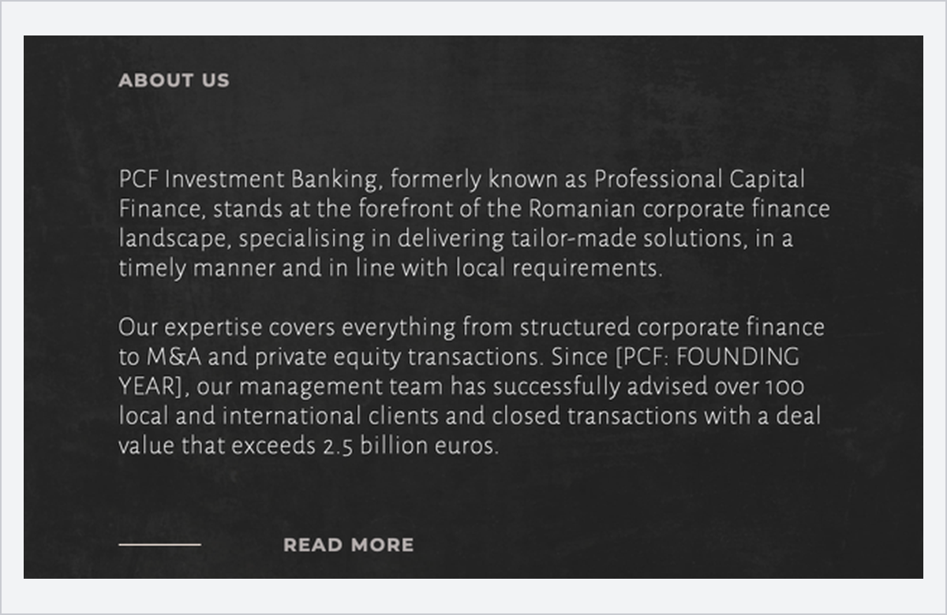
SITE NOU (PREVIEW)
About Us pe Home — anul lipsește
Figura 1. Home Page — secțiunea About Us.
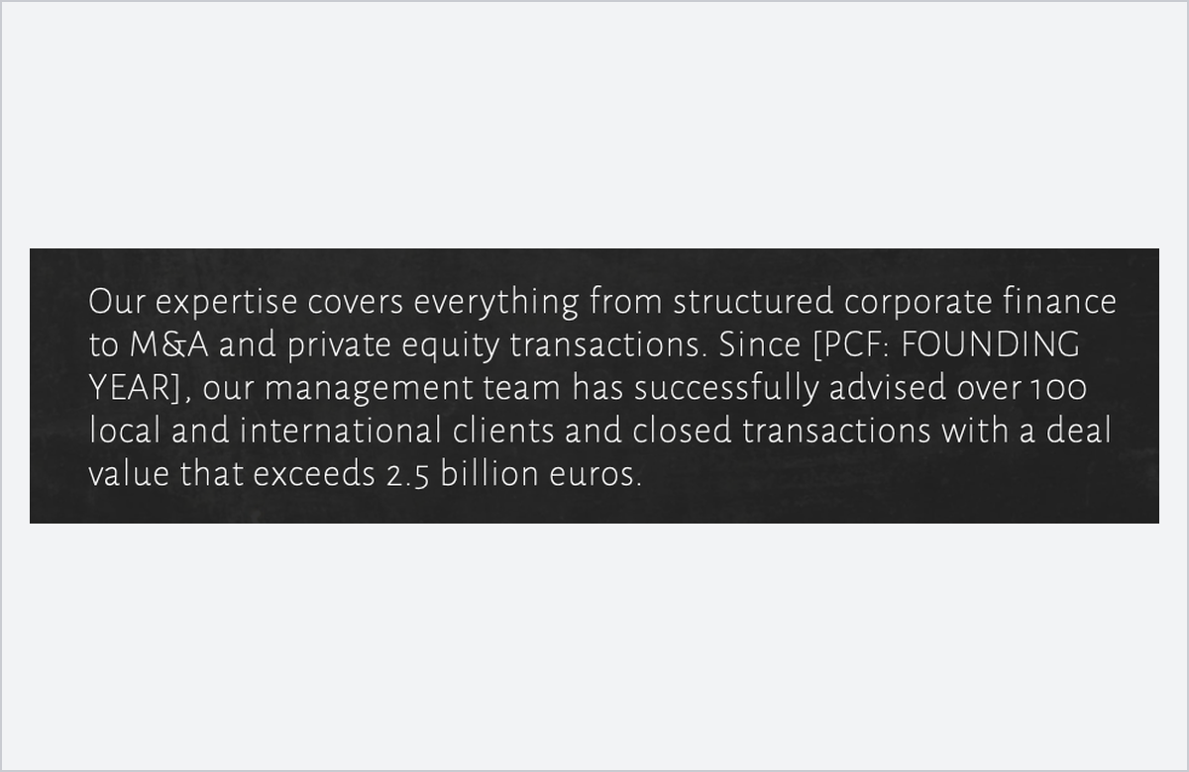  SITE NOU (PREVIEW)  Aici se pune „Since 2011” | 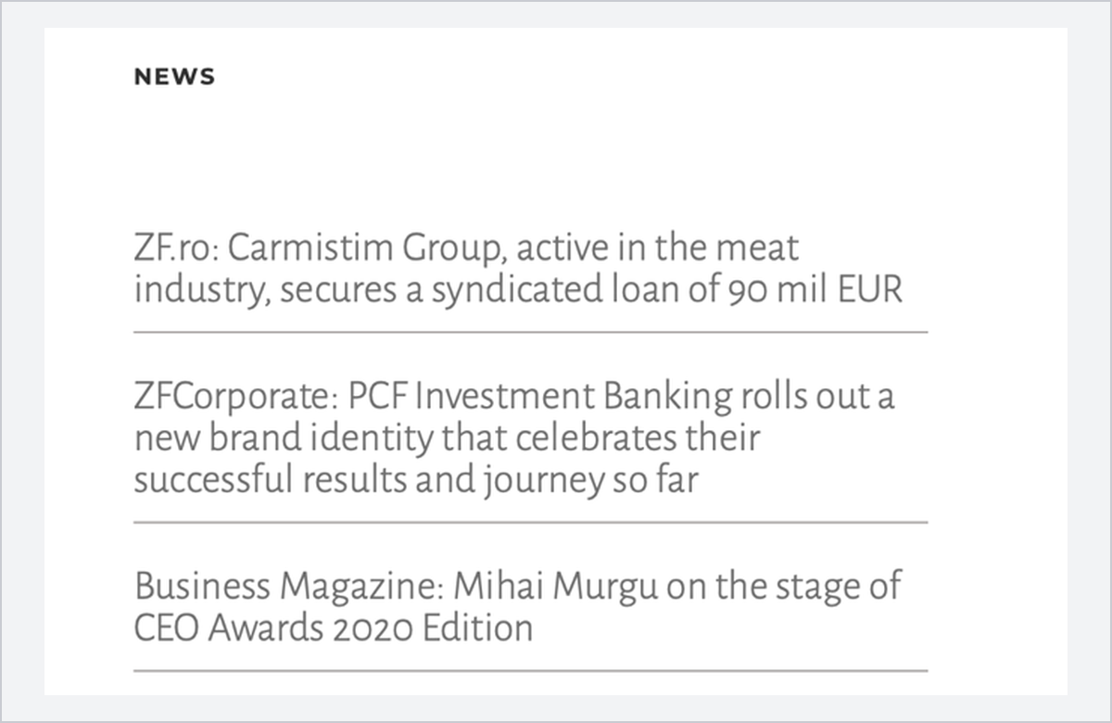  SITE NOU (PREVIEW)  Secțiunea NEWS de pe Home — se elimină stirea cu Murgu
Figura 2. Home Page — anul înființării și secțiunea NEWS.
3. About Us
- Se actualizează pagina About Us (istoric, servicii, cifre-cheie). Pe Home rămâne doar varianta scurtă.
- „Since [PCF: founding year needed]” → „Since 2011”.
TEXT PROPUS — PAGINA ABOUT US (EN)
PCF is an independent Romanian investment banking boutique. Since 2011, we have advised companies and their shareholders on structured corporate finance and debt advisory, syndicated and club loans, project finance, debt restructuring, M&A and private equity transactions.
We serve a broad range of industries, from agribusiness and food production to real estate, energy, pharma and manufacturing. Each mandate is managed end-to-end, from the initial assessment to closing, and delivered as a tailor-made solution, in a timely manner and in line with local market requirements.
To date, our team has advised more than 100 local and international clients and closed transactions with a total value exceeding EUR 2.5 billion, working alongside the leading Romanian and international banks, as well as private equity and private debt investors.
As an independent boutique, our advice is driven by our clients’ interests and essential objectives. Our partners are directly involved in every mandate, from the first assessment to closing, and our long-standing relationships with more than 20 banks and institutional investors active in Romania give our clients access to the full range of financing options available on the market.

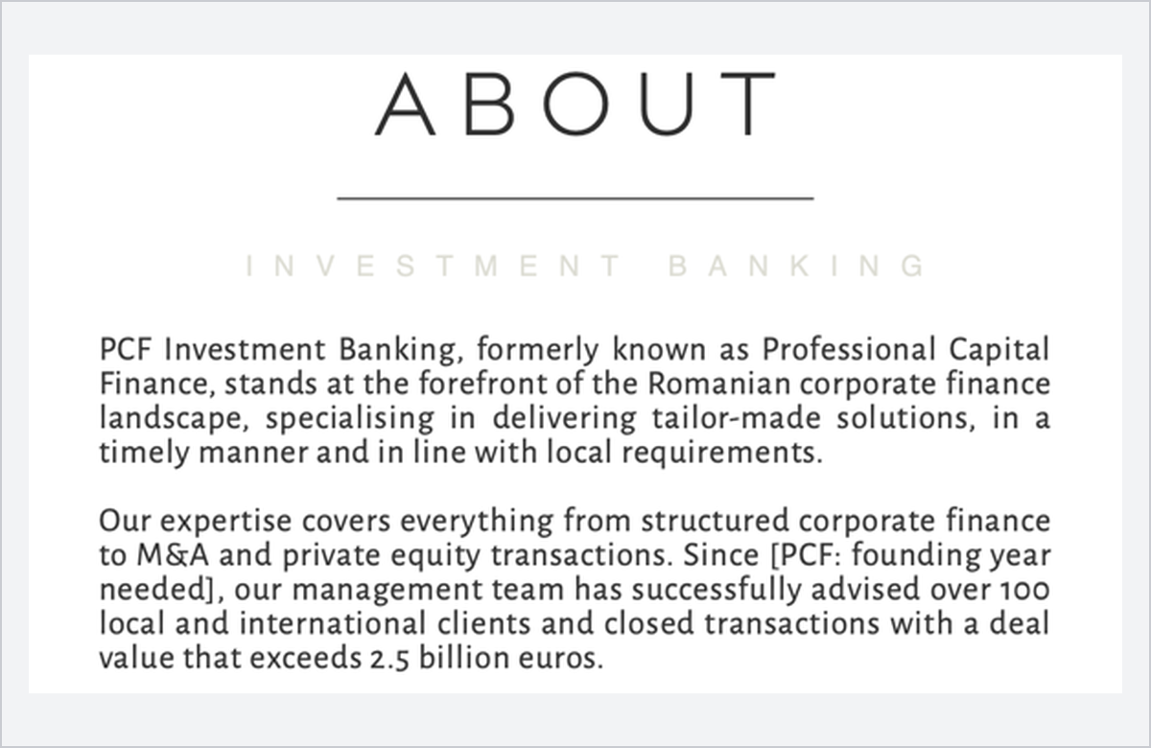
SITE NOU (PREVIEW)
Pagina About Us
Figura 3. Pagina About Us.
4. Expertise
- La fel, „Since 2011” în textul de introducere.
- După secțiunea Syndication & Club Loans se adaugă o secțiune nouă: Debt Restructuring.
- La Mergers and Acquisitions, pe lângă Sell Side și Buy Side, se adaugă box-urile Leveraged Buy-Out (LBO) și Management Buy-Out (MBO); textele Sell Side și Buy Side se reformulează, astfel încât cele patru box-uri să aibă aceeași lungime și același ton.

TEXT PROPUS — EXPERTISE (EN)
Introducere: Since 2011, we have actively witnessed the transformation of the local market and helped our customers better understand and navigate complex financial processes from structured corporate finance to private equity and M&A deals.
The combined work experience of our senior team, together with a deep understanding of the Romanian financial market, gave us a distinctive perspective. We gathered insights of the many challenges that both local and international companies face today in dealing with a volatile and ever-changing landscape and transformed them into assets.
Our work begins with understanding all the aspects of our clients’ business, their needs and expectations and assessing the right partners to achieve maximum results

Debt Restructuring (secțiune nouă): We advise companies whose debt no longer matches their cash flows. We reassess the existing financing and design the solution, extending or rescheduling maturities, consolidating facilities, renegotiating terms and covenants or bringing in new lenders, so that debt service reflects the company’s real repayment capacity. Our team prepares the financial analysis and the restructuring proposal, leads the negotiations with existing and new financiers and sees the new structure through to full implementation.

Sell Side (text reformulat): We run the sale process for shareholders seeking a full or partial exit, with one objective: maximising value while protecting the seller’s interests at every stage. We prepare the company for sale, identify and profile the most suitable strategic and financial buyers, run a competitive process and manage due diligence and negotiations through to closing. We anticipate the buyers’ questions, keep the process on schedule and secure the best achievable terms for our client.

Buy Side (text reformulat): We guide companies and investors on acquisitions, from target identification to closing, including leveraged and management buy-outs. Starting from the client’s strategic rationale, we screen the market, approach selected targets, build the valuation and transaction structure and arrange the acquisition financing where required. We coordinate due diligence and lead the negotiations with the sellers and their advisors, ensuring that the price, structure and terms agreed reflect the real value and risks of the business acquired.

Leveraged Buy-Out (box nou la M&A): We advise financial investors and management teams on leveraged buy-outs and arrange the acquisition financing, combining equity with acquisition debt to acquire the target company. We assess the target’s cash-flow capacity and debt-service headroom, design the optimal mix of equity and debt and arrange the acquisition financing with banks or private lenders, from term sheet to closing. Our track record includes the leveraged buy-out club loan arranged for Aaylex Group for the acquisition of Banvit Foods Romania, alongside the M&A advisory on the transaction.
Management Buy-Out (box nou la M&A): We advise management teams on buy-outs and arrange the financing, enabling them to acquire the companies they run, either independently or alongside financial investors. We assess the value of the business, structure the transaction and design a financing mix of management equity, investor capital and acquisition debt that is sustainable for the company and achievable for the team. We then lead the negotiations with the selling shareholders, investors and lenders, from the first offer through to closing and the implementation of the new ownership structure.

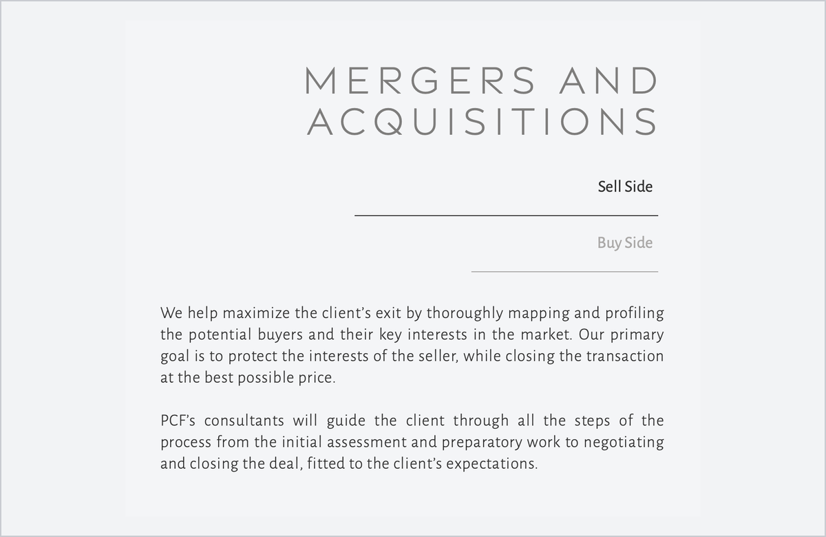
SITE NOU (PREVIEW)
Figura 4. Mergers and Acquisitions — aici se adaugă box-urile LBO și MBO.
5. Portfolio
- Selectăm cei mai importanți clienți și cele mai importante tranzacții și actualizăm logo-urile.
- Eliminăm firmele mici, cum ar fi Bio Danubius.
- Cocorico coboară undeva la mijlocul listei.
- Când se dă click pe un client, tranzacțiile apar de la cea mai recentă la cea mai veche.
Ordinea clienților în grilă
Ordinea în grilă e de la stânga la dreapta, de sus în jos:
- Criteriul 1 — longevitatea: câți ani lucrează clientul cu PCF (prima → ultima tranzacție), doar clienți activi după 2020.
- Criteriul 2 — cei mai mari clienți (dacă nu sunt deja la criteriul 1): volumul total finanțat prin PCF.
- Criteriul 3 — mărimea tranzacției: cea mai mare tranzacție individuală.
# | CLIENT | COLABORARE | VOLUM TOTAL (≈ €) | CEA MAI MARE TRANZACȚIE | CRIT.
1 | Rodbun Group | 2018–2026 · 9 ani | ≈ 375 mil | €101,5 mil sindicalizat (2023/24) | 1
2 | Carmistin Group | 2017–2024 · 8 ani | ≈ 400 mil | RON 836 mil sindicalizat (2022) | 1
3 | MG Tec Group | 2019–2026 · 8 ani | ≈ 120 mil | €50 mil multi-purpose (2026) | 1
4 | Globalworth | 2024 | ≈ 95 mil | €95 mil Campus Financing | 2
5 | Pet Star Holding | 2025 | ≈ 50 mil | €50 mil multi-purpose | 2
6 | Vox Property Group | 2020–2022 | ≈ 42 mil | €14,5 mil Vox Vertical Village | 2
7 | Sarmis Capital | 2024 | ≈ 40 mil | €40 mil Private Equity Buy Side (MG Tec Group) | 2
8 | Urgent Cargus | 2017 | ≈ 32 mil | €27,6 mil term loan | 2
9 | Coop. Podișul Transilvaniei | 2026 | ≈ 30 mil | €30 mil multi-purpose | 2
10 | Liebrecht & wooD | 2020 | ≈ 24 mil | €16,7 mil equity refinancing | 2
11 | Samus Tec | 2019 | ≈ 13 mil | €13,4 mil multipurpose | 3
12 | Cocorico / Aaylex Group | 2015–2025 · 11 ani | ≈ 355 mil | €87,1 mil sindicalizat (2022) | mijloc
13 | Diana Group | 2024 | ≈ 10 mil | €10 mil M&A buy-side (Univers) | 3
14 | Gates Air | 2019 | ≈ 11 mil | €10 mil project finance | 3
15 | FCC & Azvi | 2014–2016 | ≈ 9 mil | €8,5 mil factoring | 3
16 | Versus Pharma Group | 2025 | ≈ 8 mil | €8 mil working capital | 3
17 | Frizon Group | 2024–2025 | ≈ 15 mil | €7,5 mil loans rearranging | 3
18 | Alpenside | 2019–2020 | ≈ 12 mil | €6,2 mil factoring | 3
19 | G&M Group | 2019–2020 | ≈ 7 mil | RON 26,8 mil refinanțare | 3
20 | Biharia Office | 2024–2025 | ≈ 9 mil | €5 mil equity refinancing | 3
21 | Aktor (Ellaktor) | 2016–2018 | ≈ 8 mil | €5 mil factoring | 3
22 | Campeador | 2020–2021 | ≈ 8 mil | RON 24 mil project finance | 3
23 | Sels Agro | 2020–2025 · 6 ani | ≈ 9 mil | €5 mil Exim (2025) | 1
- Se scot (mici sau vechi): Bio Danubius, Prutul Agri Trade, Romkatel, Pharmnet Plus, Frontera, Noodle Pack, Urgent Curier, V&G Oil.
Tranzacții pentru clienții actualizați și adăugați (cele mai recente primele)
Din inregistrarile PCF 2020–2026; acolo unde nu există inregistrare, sursa e indicată. „Nou” = client care nu era pe pcf.ro; „Actualizat” = client existent, cu tranzacții noi sau valori corectate.
AN | TRANZACȚIE | VALOARE
Rodbun Group — actualizat
2025–2026 | Syndicated Green Loan — Afforestation | EUR 40,000,000
2025 | Syndicated Loan — Working Capital Facility | EUR 17,500,000
2024 | Frontier Invest Group — Farm Acquisition Financing | EUR 3,300,000
2024 | Syndicated Loan (coordonat de BCR) | EUR 101,500,000
2022 | Syndicated Facility — RON/EUR Conversion | EUR 65,000,000
2021 | Syndicated Loan | RON 278,000,000
2021 | Syndicated Loan (Exim) | RON 84,500,000
2021 | Syndicated Loan Top-Up Facility | RON 68,000,000
Carmistin Group — actualizat
2024 | Syndicated Loan — pig slaughterhouse project | EUR 81,000,000
2024 | Project Finance — Pigtim (Banca Transilvania) | EUR 13,800,000
2022 | Syndicated Loan | RON 836,000,000
2021 | Syndicated Loan Top-Up Facility | RON 209,000,000
2021 | APIA Subsidies Financing | RON 11,000,000
2020 | Syndicated Loan | RON 427,000,000
MG Tec Group — actualizat
2026 | Multi-Purpose Loan | EUR 50,000,000
2024 | Working Capital Facility (Garanti BBVA) | EUR 7,500,000
2021 | Working Capital Facility | EUR 10,000,000
2020 | Working Capital Facility | EUR 5,000,000
Sels Agro — nou
2025 | Working Capital with EXIM guarantee | EUR 5,000,000
2021 | Multiproduct Facility for Working Capital | RON 15,000,000
2020 | IMM Invest Working Capital Facility | RON 5,000,000
Globalworth — nou
2024 | Globalworth Campus Financing (Erste Bank) | EUR 95,000,000
Pet Star Holding — nou
2025 | Multi-Purpose Loan (UniCredit) | EUR 50,000,000
Vox Property Group — actualizat
2021–2022 | Project Finance Facility — Vox Vertical Village | EUR 14,500,000
2021 | Project Finance Facility — Vox Vertical Village | EUR 10,500,000
2021 | Equity Refinancing | EUR 8,500,000
2021 | Equity Refinancing | EUR 4,000,000
2020 | Non-Cash Facility — Performance Bond for PORR | EUR 4,700,000
Sarmis Capital — nou
2024 | Private Equity Buy Side — acquisition of a majority stake in MG Tec Group | EUR 40,000,000
Coop. Agricolă Podișul Transilvaniei — nou
2026 | Multipurpose Financing Facility (investment loan EUR 17.0M, bridge loan EUR 9.75M, VAT facility RON 15.0M) | EUR 30,000,000
Liebrecht & wooD — actualizat (valoare corectată)
2020 | Equity Refinancing — Fashion House 1 Militari (Hypo NOE) | EUR 16,700,000
2020 | Project Finance — Fashion House 2 Cernica (CEC Bank) | EUR 7,500,000
Cocorico / Aaylex Group — actualizat
2025 | INVESTALIM State-Aid Loan | EUR 37,000,000
2025 | Investment & Working Capital Facility | EUR 14,500,000
2024 | „5 x APIA” Subsidies Financing | EUR 28,000,000
2024 | Club Loan — Working Capital Facility (CEC, Alpha Bank) | EUR 20,000,000
2022 | Syndicated Loan | EUR 87,100,000
2021 | M&A — Buy Side | EUR 20,300,000
2021 | Acquisition Finance & Working Capital | EUR 20,000,000
2021 | Working Capital with Covid-19 Exim Guarantee | RON 53,000,000
2021 | APIA Subsidies Financing | RON 28,000,000
2020 | APIA Subsidies Financing | RON 30,000,000
2020 | Refinancing & New Working Capital Facility (Aaylex Agro Cooperativa) | RON 30,000,000
Diana Group — nou
2024 | M&A — Buy Side (Univers S.A.) | EUR 10,000,000
Versus Pharma Group — nou
2025 | Cash & Non-Cash Working Capital Facilities | EUR 8,000,000
Frizon Group — nou
2025 | Loans Rearranging | EUR 7,500,000
2024 | Working Capital Facility — Farmer Loan Product (CEC Bank) | EUR 7,000,000
Alpenside — actualizat
2020 | Advance Payment Guarantee & Direct Factoring — Iași–Suceava road project | RON 17,000,000
2020 | Non-Recourse Factoring Facility | RON 13,000,000
G&M Group — actualizat
2020 | Refinancing Facilities & New Short-Term Loan (CEC Bank) | RON 26,800,000
2020 | IMM Invest Working Capital Facility | RON 5,000,000
Biharia Office — nou
2025 | Equity Refinancing | EUR 5,000,000
2024 | Equity Refinancing (Garanti BBVA) | EUR 4,000,000
Campeador — actualizat
2021 | Project Finance Facility — Campeador City Residence (CEC Bank) | RON 24,000,000
2021 | Working Capital with Covid-19 Exim Guarantee | RON 10,000,000
2020 | Project Finance Facilities — Campeador Residence (CEC Bank) | RON 7,700,000
Urgent Cargus, Samus Tec, Gates Air, FCC & Azvi și Aktor rămân cu tranzacțiile de pe pcf.ro (
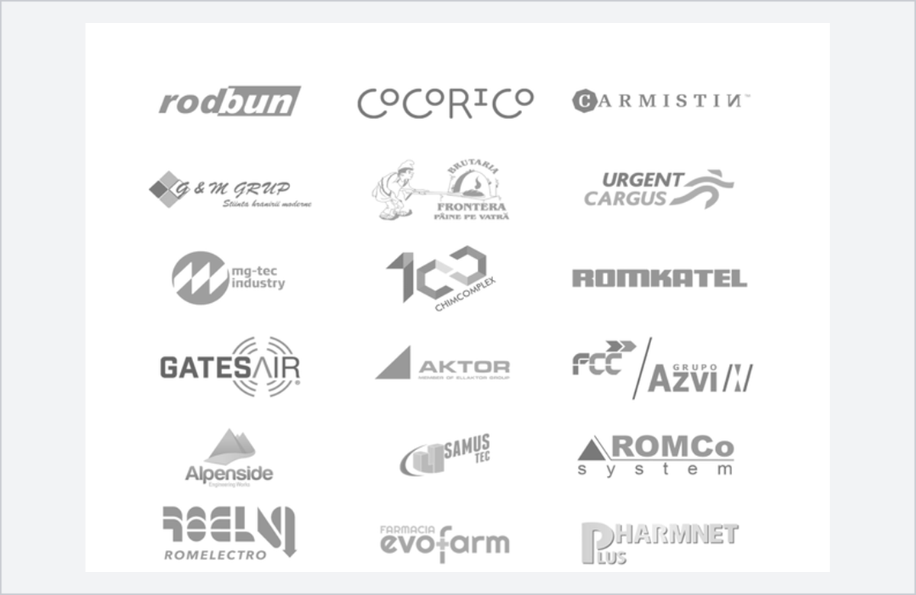  SITE NOU (PREVIEW)  Logo-uri clienți (1) | 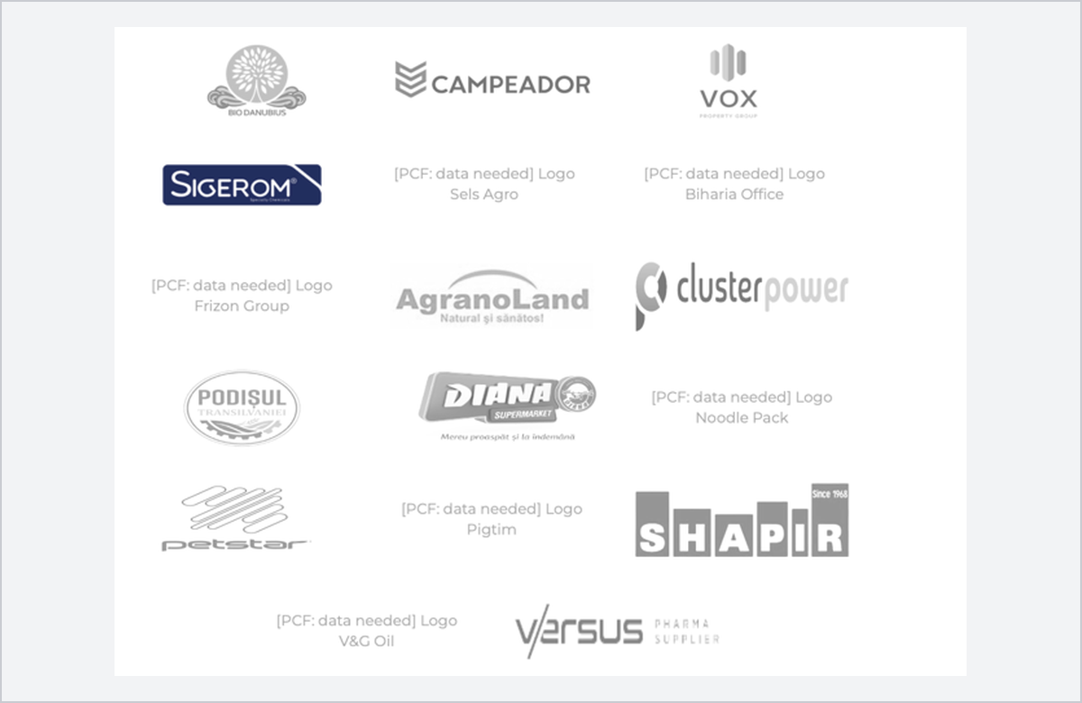  SITE NOU (PREVIEW)  Logo-uri clienți (2) — logo-uri lipsă
Figura 5. Pagina Portfolio — lista de clienți.
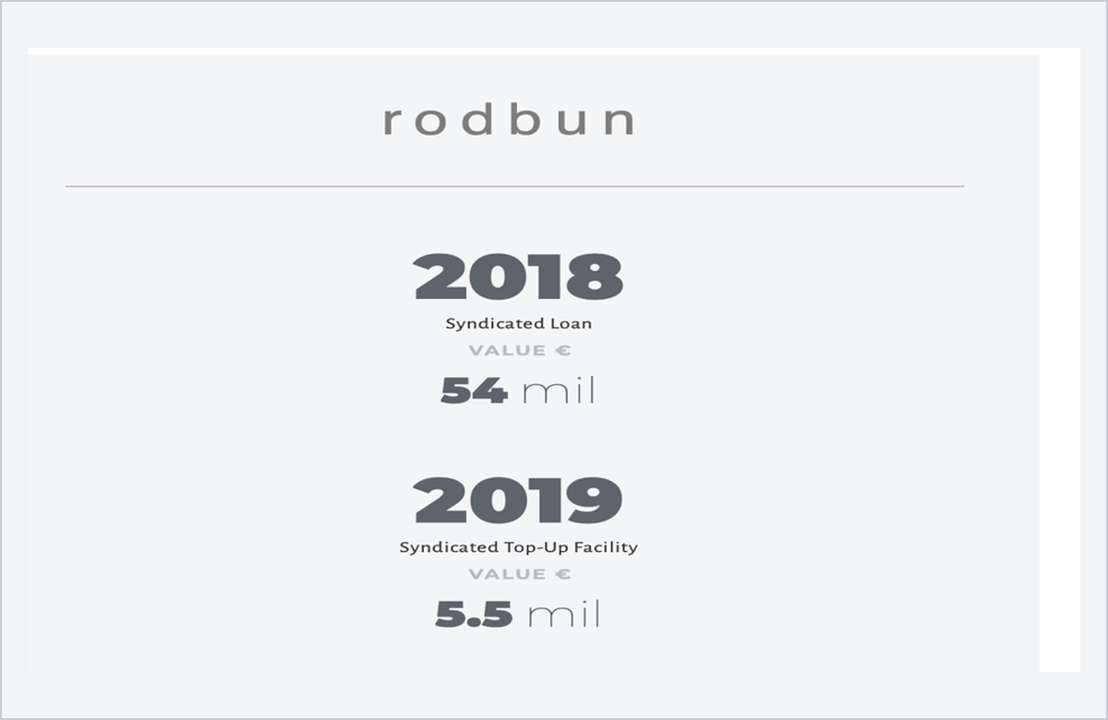
SITE NOU (PREVIEW)
Figura 6. Tranzacțiile trebuie ordonate de la cea mai recentă la cea mai veche.
6. Team
- La e-mail și LinkedIn se pun iconițe, nu text (ca pe site-ul vechi).
- Descrierile de mai jos înlocuiesc textele actuale. Fiecare membru al echipei are un short bio (afișat în grila Team) și un long bio (afișat la click / pe pagina de detaliu).
Mihai Iordan Founder & Managing Partner
Short bio
Mihai Iordan is the Founder and Managing Partner of PCF Investment Banking. With over 20 years in corporate finance, he advises shareholders and C-suite executives on structured finance, debt advisory, private equity and M&A transactions, drawing on an extensive network of banks, investors and corporate leaders across Romania and the CEE region.
Long bio
Mihai Iordan is the Founder of PCF Investment Banking, bringing deep transactional expertise across structured finance, debt advisory, private equity, and M&A. He provides strategic counsel to C-suite executives and shareholders on complex, high-stakes transactions, backed by an in-depth understanding of the Romanian financial ecosystem. He maintains an extensive institutional network spanning private equity funds, banks, and corporate leaders across Romania and the wider CEE region. Prior to founding PCF, Mihai held key corporate banking positions, including Large Corporate Banker at UniCredit, Deputy Head of Corporate at Libra Bank, having built his foundation at Ernst & Young. Further, he held management positions at Schnecker Van Wyk & Pearson Romania and was an Equity Partner at Oxygen.
Vlad Florea Director, Investment Banking
Short bio
Vlad Florea is Director, Investment Banking at PCF and leads the execution of the firm’s syndicated and club loan mandates. He joined in 2022 after serving as Senior Banker in BCR’s Large Corporate Agribusiness & Food division and as CFO of Cerealcom Dolj Group, bringing both the lender’s and the borrower’s perspective to every transaction.
Long bio
Vlad Florea joined PCF Investment Banking in 2022 as Director, Investment Banking, and leads the execution of the firm’s syndicated and club loan mandates. He brings a combined banking and corporate perspective, having worked on both sides of the financing table.
Before joining PCF, Vlad was Senior Banker in BCR’s Large Corporate Agribusiness & Food division. Earlier, he served as Chief Financial Officer of Cerealcom Dolj Group, one of Romania’s largest agricultural producers and traders, where he led the financial, accounting and reporting functions and was a key contributor to the group doubling its volumes and turnover over three years. Vlad graduated from the Faculty of Finance, Insurance, Banking and Stock Exchange and holds an MBA from the Bucharest University of Economic Studies.
Teodor Banu Director, Investment Banking
Short bio
Teodor Banu is Director, Investment Banking at PCF, with 20 years of experience in corporate banking and risk management. He joined in 2025 from OTP Bank Romania, where, as Corporate Underwriting Director, he oversaw the structuring and approval of large corporate and project finance loans across agribusiness, construction, manufacturing and real estate.
Long bio
Teodor Banu joined PCF Investment Banking in 2025 as Director, Investment Banking. He previously served as Corporate Underwriting Director at OTP Bank Romania, where he oversaw the structuring and approval of a significant number of large corporate and project finance loans across agribusiness, construction, manufacturing and real estate.
With 20 years of experience in corporate banking and risk management, Teodor has developed tailored financing solutions, from syndicated loans to credit arrangements and risk management services, helping companies grow on a sound financial footing. He brings clarity and structure to complex transactions, making sure every stakeholder understands each step and that execution remains efficient. Teodor graduated from the Faculty of Finance, Insurance, Banking and Stock Exchange at the Bucharest University of Economic Studies and holds the ACCA qualification.
Adrian Tudor Manager
Short bio
Adrian Tudor is Manager at PCF Investment Banking, supporting the execution of financing and M&A mandates across a wide range of industries. He rejoined the firm in 2024 after serving as Chief Financial Officer of a real estate group, having previously spent two years in the PCF team.
Long bio
Adrian Tudor rejoined PCF Investment Banking in 2024 as Manager. He was first part of the PCF team for two years before taking on the role of Chief Financial Officer at a real estate group, where he strengthened his leadership skills and broadened his financial expertise.
Since his return, Adrian has played a key role in executing high-impact transactions across a wide range of industries. He holds a degree from the Faculty of Finance, Insurance, Banking and Stock Exchange at the Bucharest University of Economic Studies.
Diana Anghel Office Manager
Short bio
Diana Anghel is Office Manager at PCF Investment Banking, which she joined in 2017. She oversees the firm’s administrative, operational and human resources functions, ensuring that internal processes, documentation and relationships with external partners are managed efficiently.
Long bio
Diana Anghel joined PCF Investment Banking in 2017 and has since been closely involved in the firm’s day-to-day operations. As Office Manager, she oversees the administrative, operational and human resources functions of the business, ensuring that internal processes, contracts, documentation, schedules, personnel matters and relationships with external partners are efficiently managed.
With a degree in Legal Sciences and a Master’s degree in Political Sciences, Diana brings a structured and multidisciplinary perspective to her role. Her extended experience within PCF Investment Banking allows her to provide overall support for the team and the business.

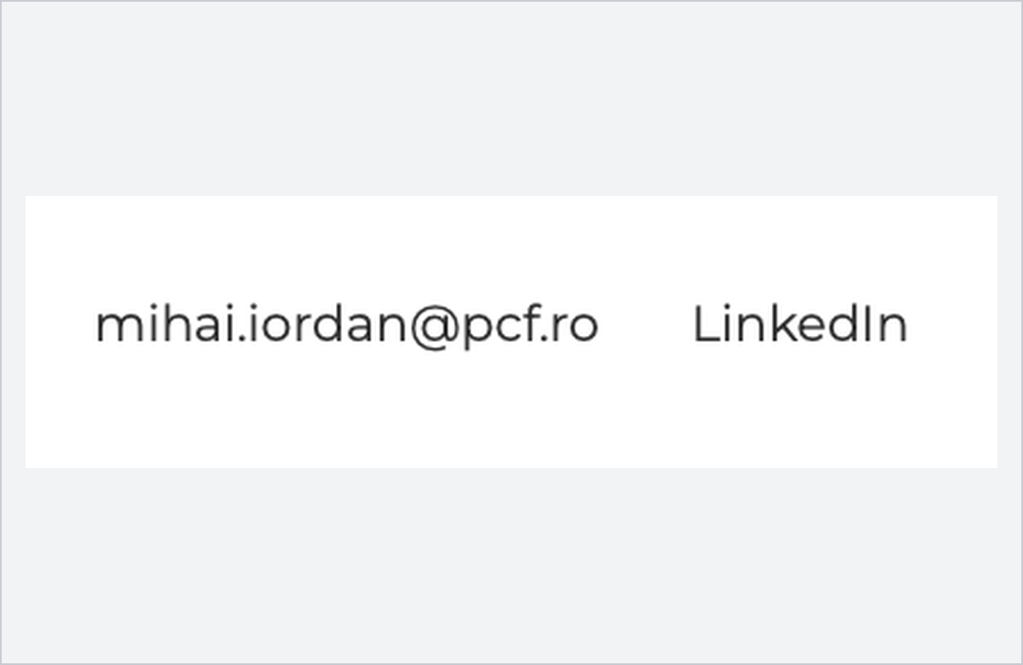  SITE NOU (PREVIEW)  Acum: text | 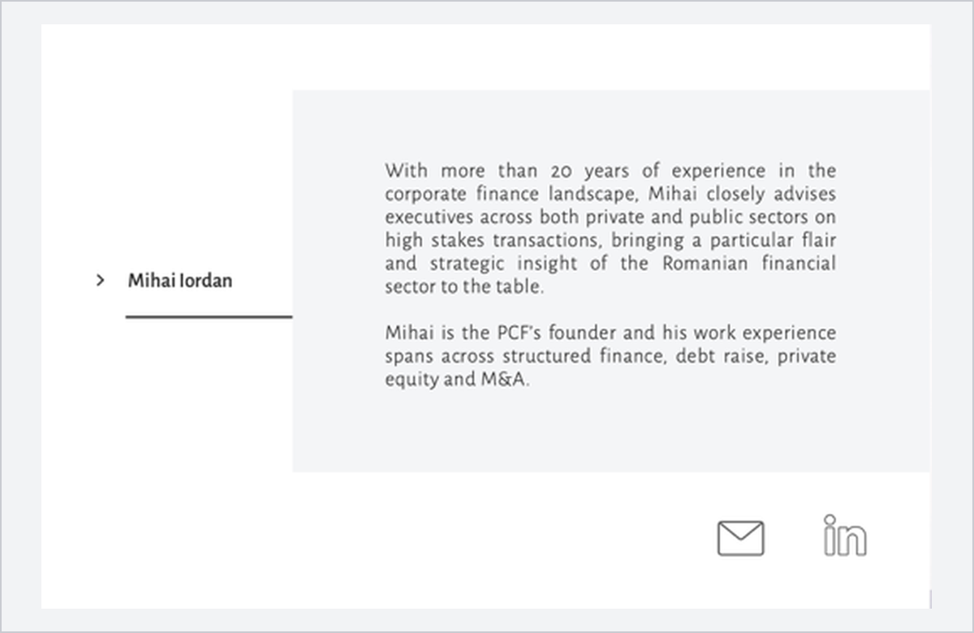  SITE ACTUAL (PCF.RO)  Cum trebuie: iconițe
Figura 7. Pagina Team — e-mail și LinkedIn.
7. News
- Ultimele articole de pe site sunt din 2020–2021.
Articole recente găsite în presă, care nu sunt pe site:
- 22.07.2025 Rodbun — credit sindicalizat €17,3 mil (Bursa)
- 01.07.2025 PetStar — finanțare €50 mil de la UniCredit (Economica.net)
- 07.10.2024 Sarmis Capital — achiziția pachetului majoritar al MG-Tec Industry (Economica.net)
- 05.03.2024 Rodbun — credit sindicalizat €101,5 mil (Ziarul Financiar)
- 27.02.2024 Carmistin — credit sindicalizat €81 mil (Profit.ro)
- 09.01.2023 Carmistin — majorare credit sindicalizat, total 846 mil. lei (Profit.ro)

TEXT PROPUS — ARTICOLE NOI PENTRU PAGINA NEWS (EN)
Rodbun Group — EUR 17.3M syndicated loan (Bursa, 22.07.2025). PCF Investment Banking acted as exclusive advisor to Rodbun Group in arranging a EUR 17.3 million syndicated loan backed by a State guarantee. BCR acted as facility agent, security agent and lender, alongside CEC Bank, ING Bank Romania and Garanti BBVA, with Exim Banca Românească as guarantor. The facility supports the group’s working capital and development plans.
PetStar Group — EUR 50M financing from UniCredit Bank (Economica.net, 01.07.2025). PetStar Group, together with PCF Investment Banking as exclusive arranger, secured a EUR 50 million multi-tranche facility from UniCredit Bank to support the accelerated development of its business.
Sarmis Capital — acquisition of a majority stake in MG-Tec Industry (Economica.net, 07.10.2024). PCF Investment Banking acted as financial advisor to SARMIS Capital on the acquisition of a majority stake in MG-Tec Industry, one of Romania’s largest independent tissue paper producers, with a turnover of EUR 58 million in 2023 and over EUR 150 million invested in its greenfield production platform in Dej. The transaction, approved by the competition authority, marks the entry of SARMIS Capital into the tissue paper sector and the second investment of its founding team in the industry.
Rodbun Group — EUR 101.5M syndicated loan (Ziarul Financiar, 05.03.2024). PCF Investment Banking acted as exclusive advisor to Rodbun Group in structuring, negotiating and implementing a EUR 101.5 million syndicated loan coordinated by BCR, for working capital and the expansion of the business.
Carmistin Group — EUR 81M syndicated facility (Profit.ro, 27.02.2024). With PCF Investment Banking as financial advisor, Carmistin Group secured a EUR 81 million syndicated facility arranged by BCR, with ING, UniCredit, OTP Bank, Alpha Bank, Garanti BBVA and Banca Transilvania, to build the largest pig slaughterhouse in Romania.
Carmistin Group — RON 846M syndicated loan (Profit.ro, 09.01.2023). PCF Investment Banking assisted Carmistin Group in the partial conversion into euro and the RON 218 million increase of its existing syndicated loan, bringing the total facility to RON 846 million.
8. CSR
- La pagina CSR punem datele cele mai relevante pentru fiecare asociație (ce face, o cifră-cheie, cum o sprijină PCF).
TEXT PROPUS — CSR (EN)
Asociația Magic: Since 2014, Asociația Magic has run MagiCAMP, summer camps for children living with serious illness or who have lost a loved one, with round-the-clock medical and psychological support, alongside programmes such as MagicHome and the MagicEdu scholarships. More than 2,100 children have taken part in its camps. PCF has supported the association since 2019, backing Vlad Crișan Pop’s Arctic Ultra 6633 (2019–2021) and Elbrus (2021) challenges, which raised funds for MagicEdu scholarships.

Centrul de zi Aurora: Founded in 1995 by ASCHF-R together with Handicap International, Centrul de zi Aurora in Bucharest provides special education, kinetotherapy, speech therapy and socialisation for children with severe neuromotor disabilities, including daily transport with an adapted bus. Over the years it has supported more than 165 children and helped dozens of them integrate into mainstream schools.
Ecoland Academy: Ecoland Academy is a Romanian initiative focused on supporting athletes through education, professional development and community engagement. By connecting sporting activities with learning opportunities and personal development, the Academy aims to help athletes build transferable skills and prepare for opportunities beyond their competitive careers.

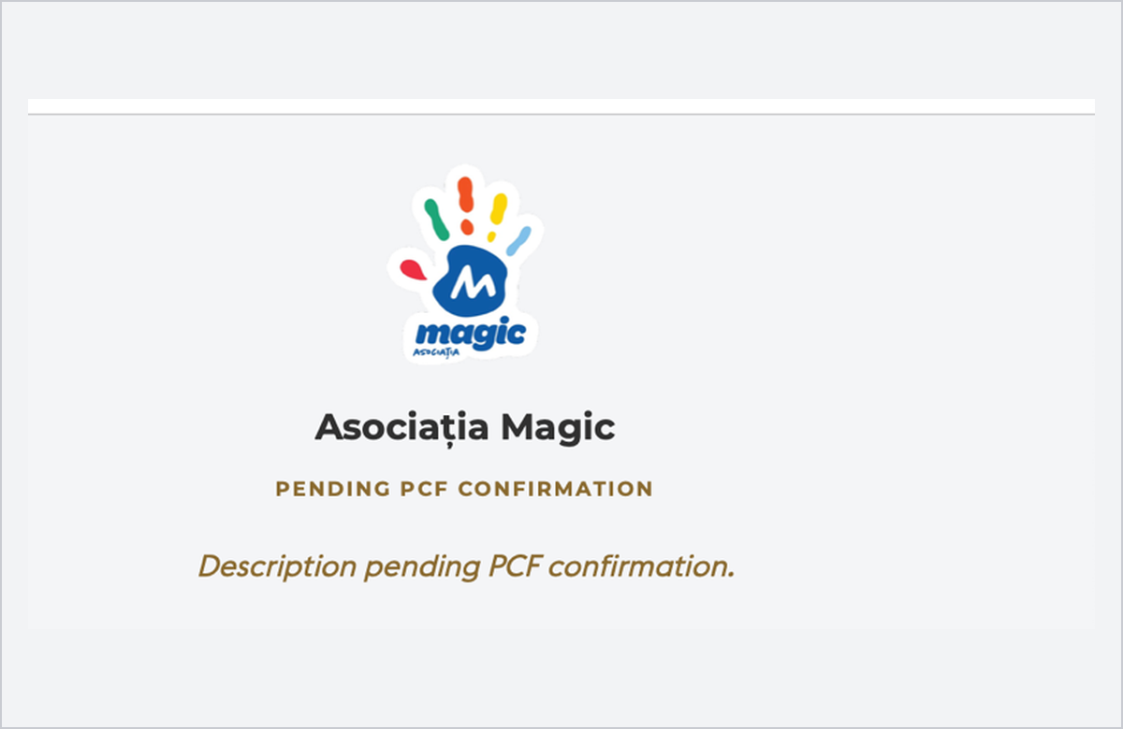
SITE NOU (PREVIEW)
CSR — Asociația Magic, fără date
Figura 8. Pagina CSR.
9. Logo-uri de adăugat
Cele 5 logo-uri care lipsesc de pe preview, în ordinea din grila de 23 de la pct. 5 (poz. = poziția din tabel):
 | 
Globalworth · poz. 4 | Liebrecht & wooD · poz. 10
 |  | 
Frizon Group · poz. 17 | Biharia Office · poz. 20 | Sels Agro · poz. 23

